**LUWERO EXAMINATIONS BOARD**

**BEGINNING OF TERM I EXAMINATIONS 2024**

**BABY CLASS**

**ENGLISH**

Name……………………………………………………

Read letters orally

A b c d e f g

H i j k l m n

O p q r s t u

V w x y z

Trace triangle

5.Colour letter “c” and its friend

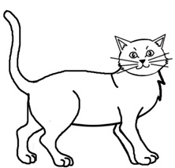



Write letter

A a a

Colour things at home